AYURVEDA PG ORIENTATION PROGRAM SUMMARY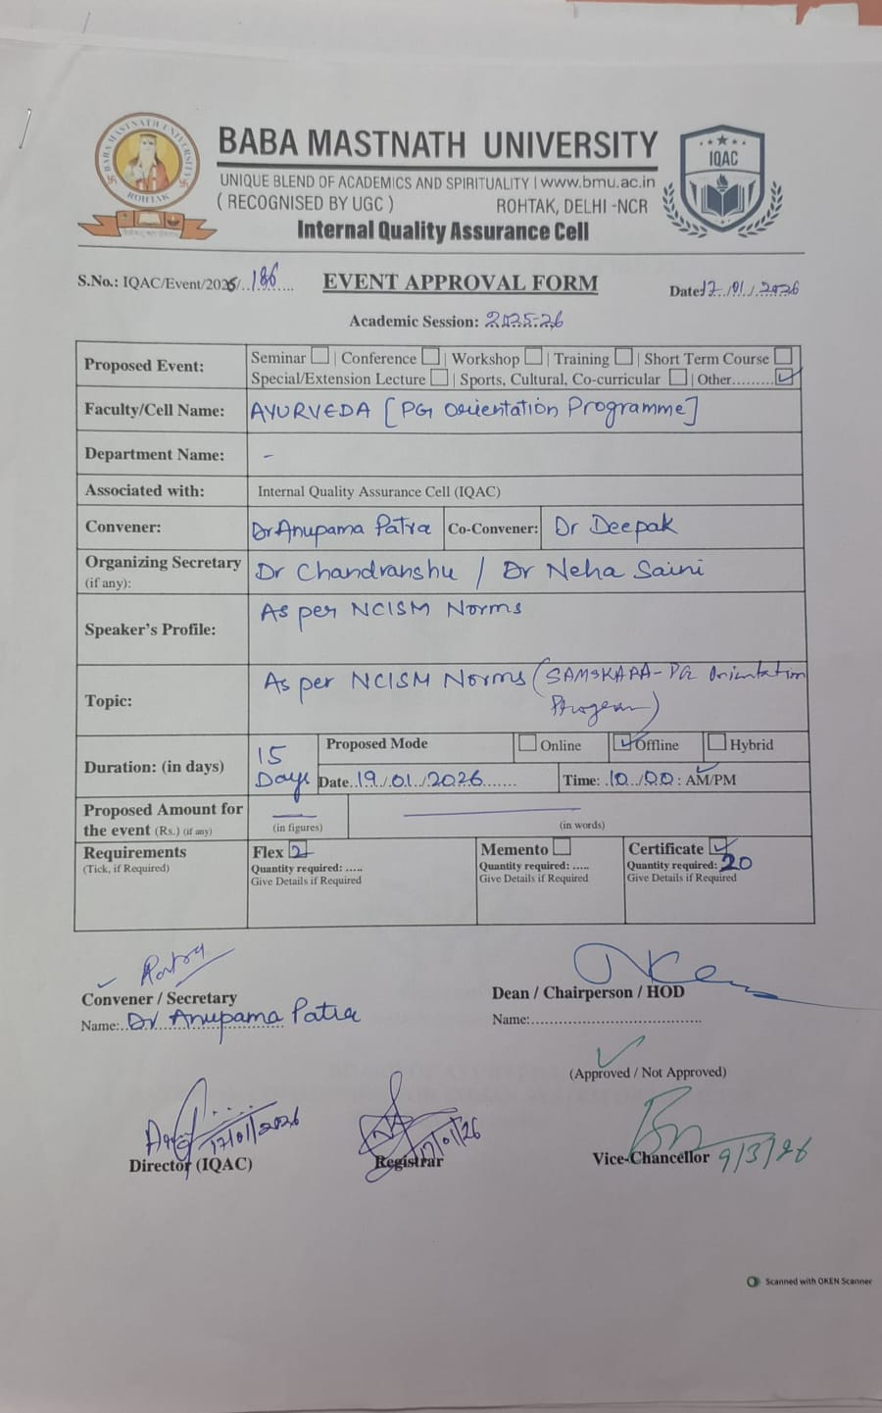

PG ORIENTATION PROGRAM SCHEDULE

INAUGRATION CEREMONY
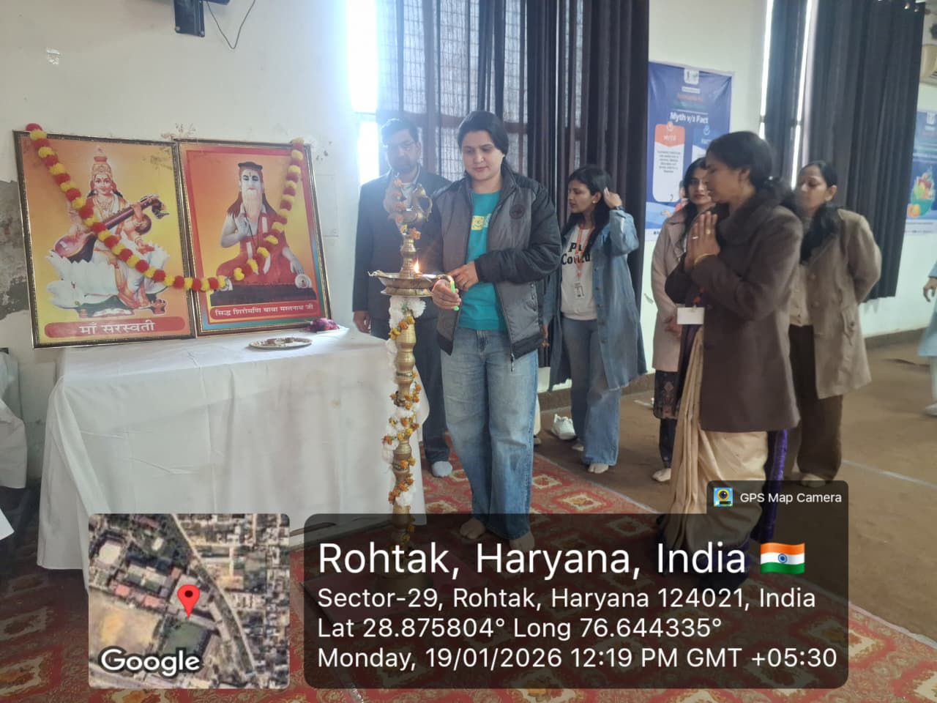

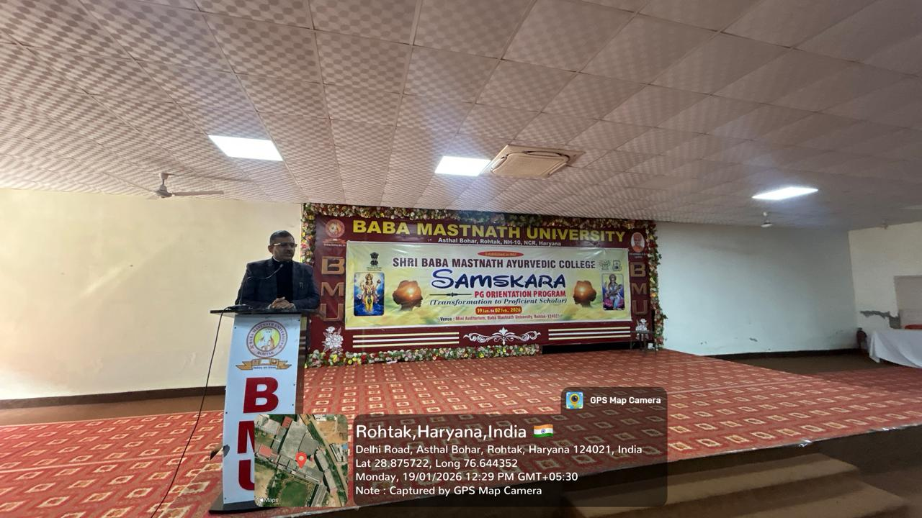

WELCOME OF PG STUDENTS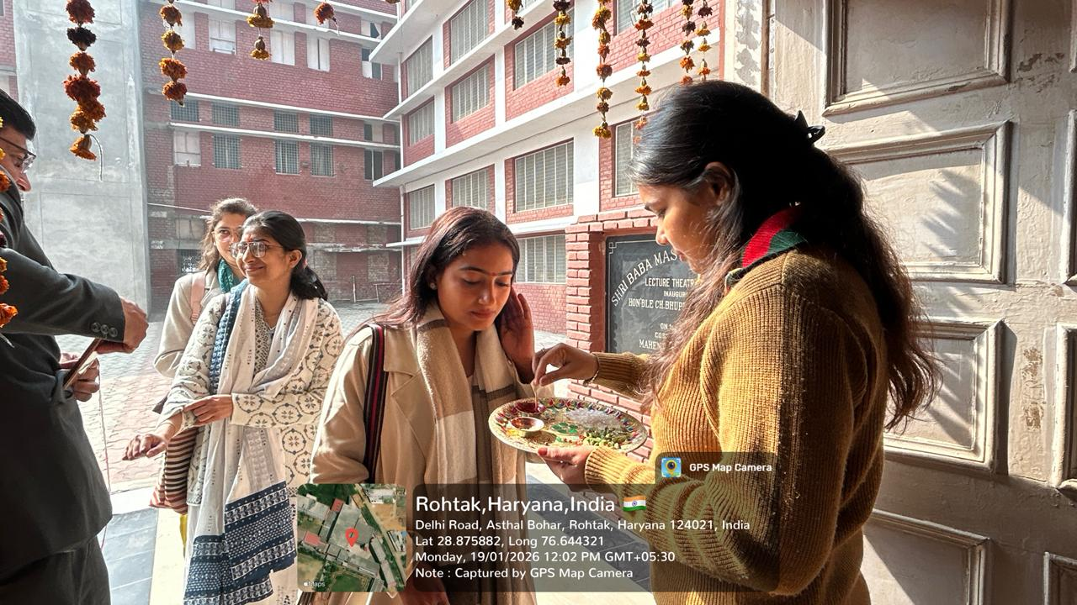

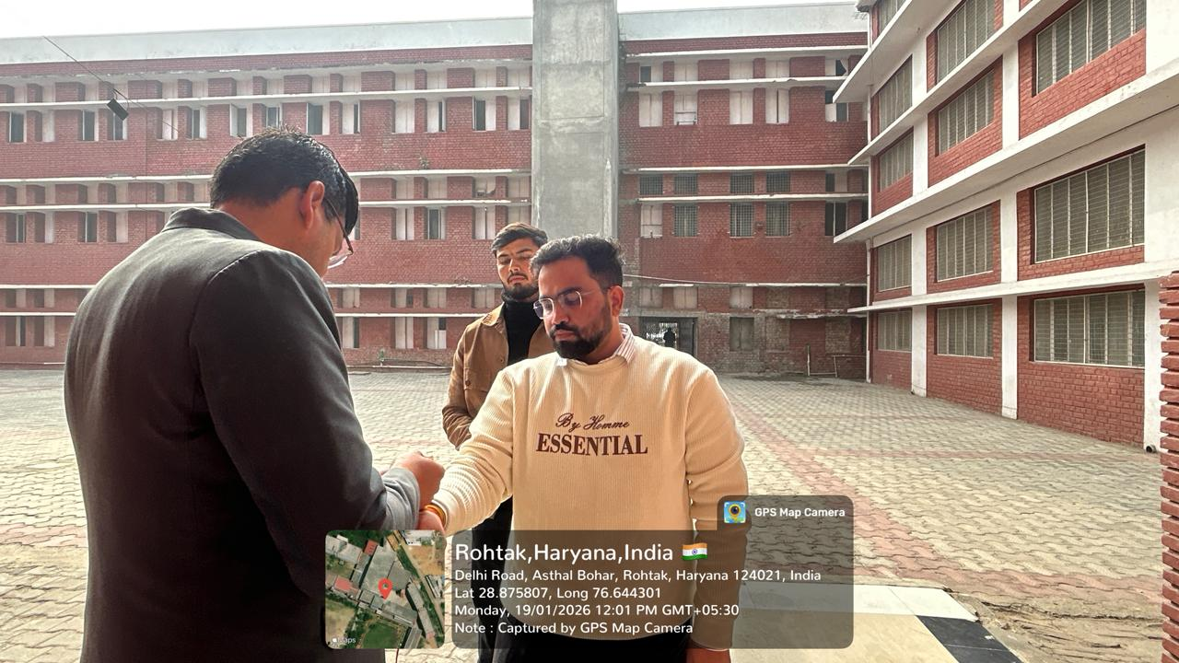

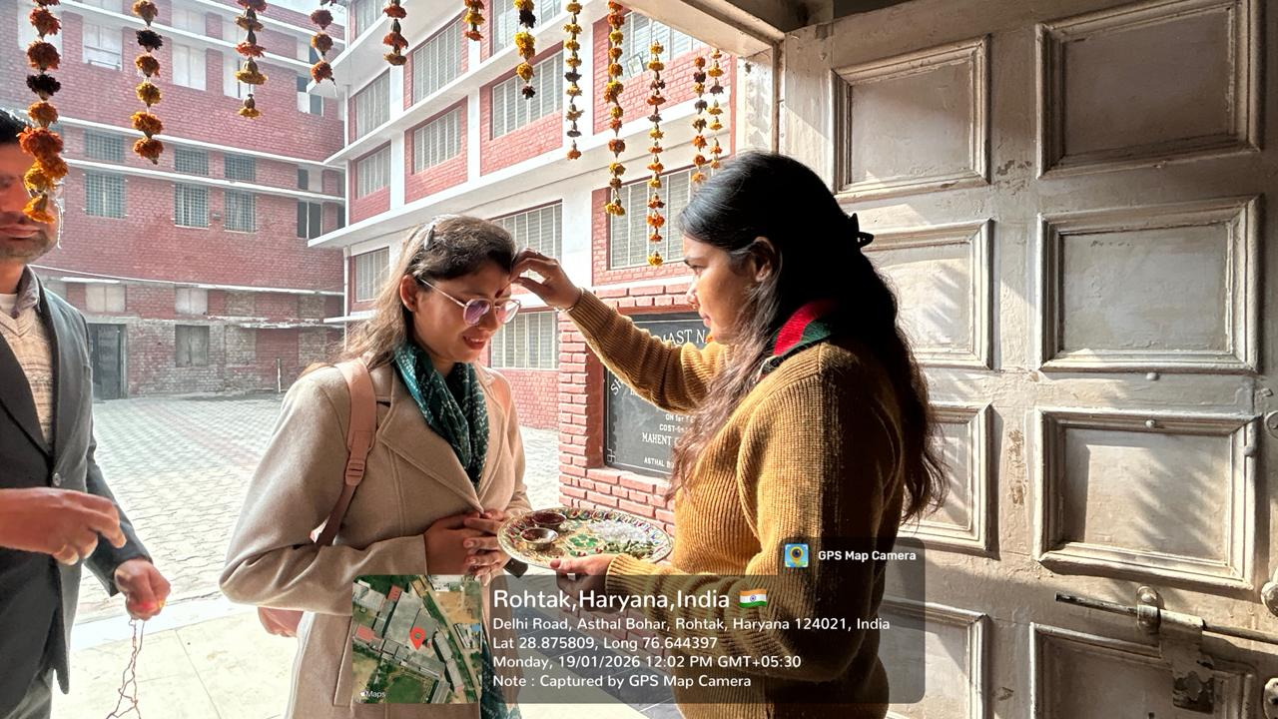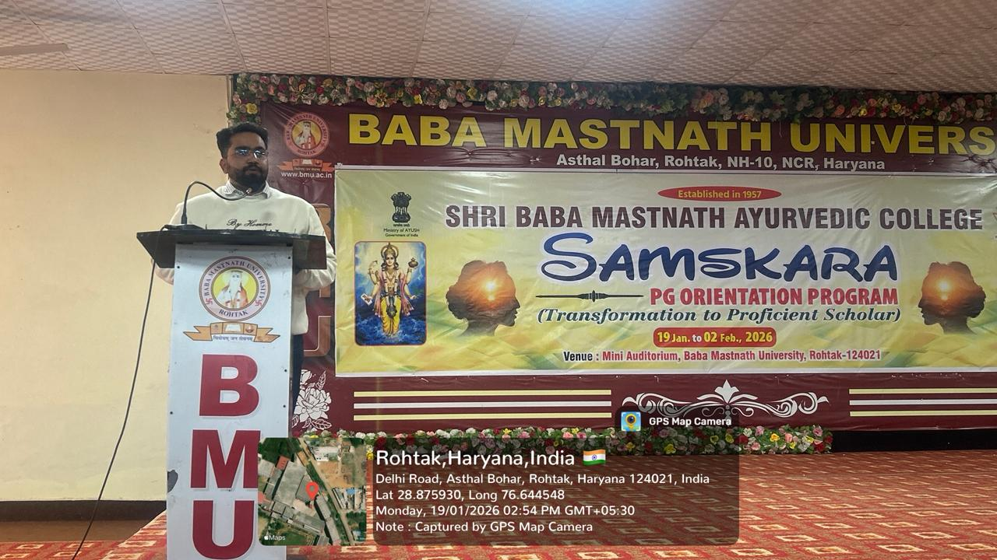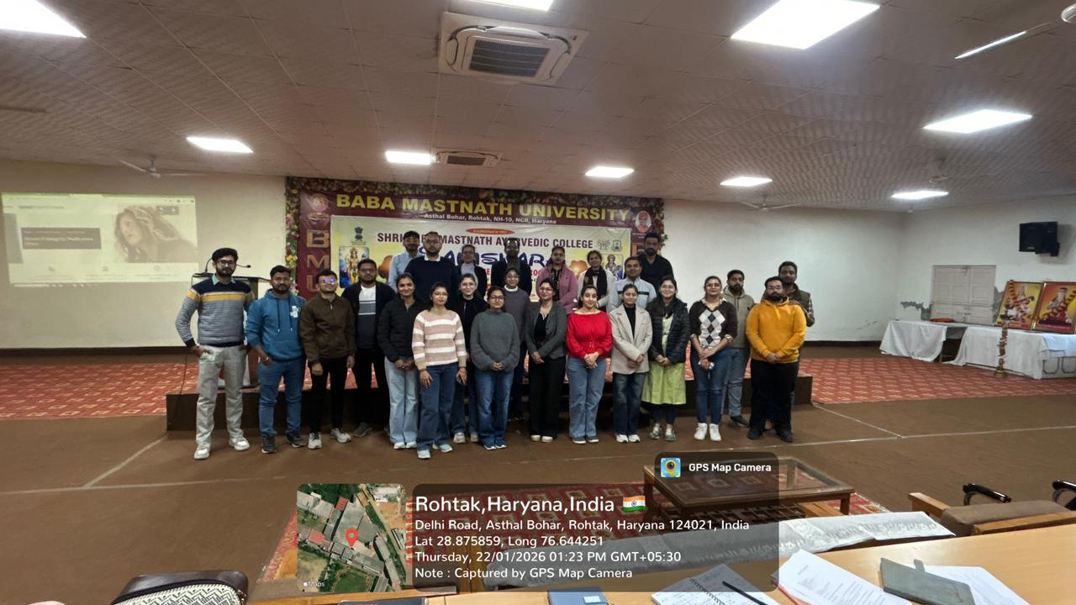

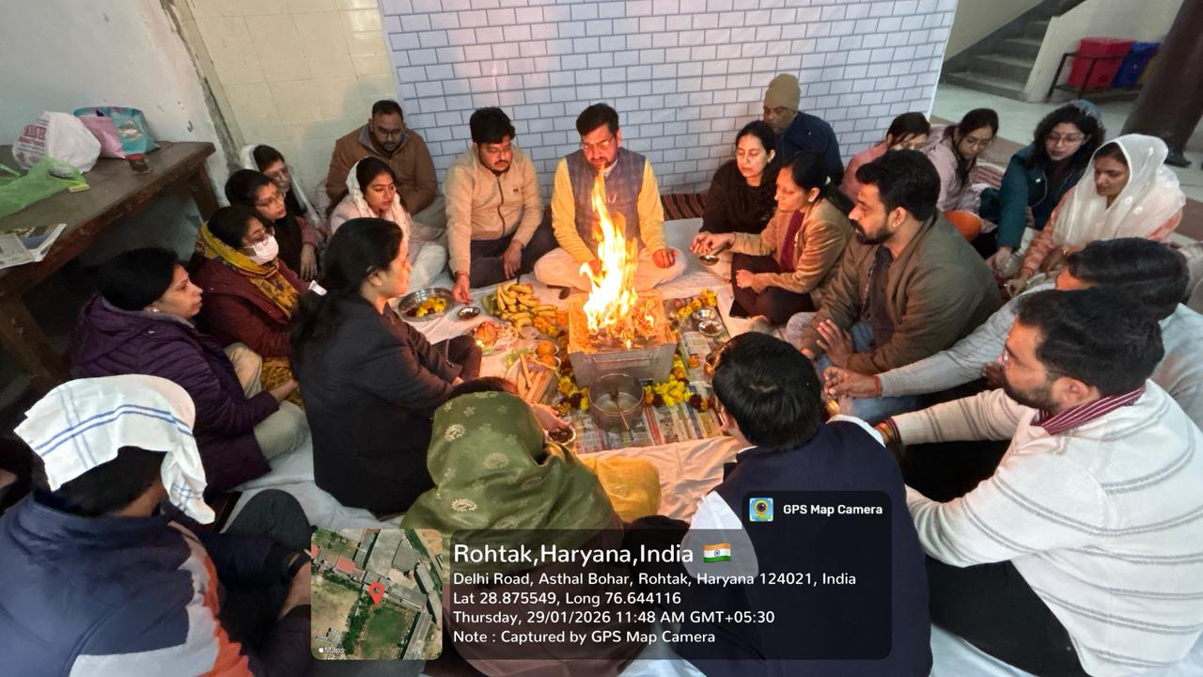

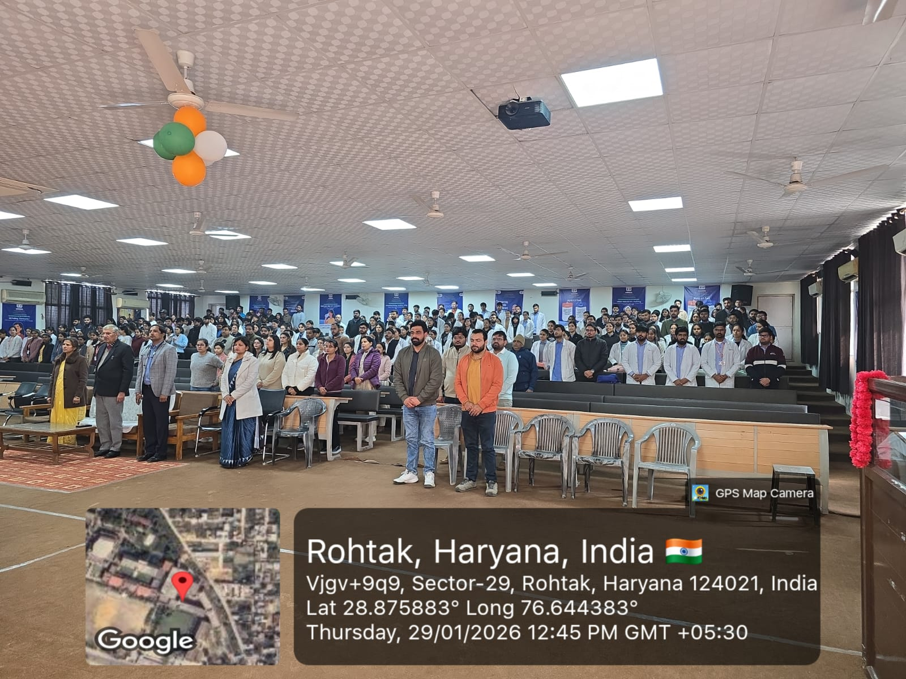

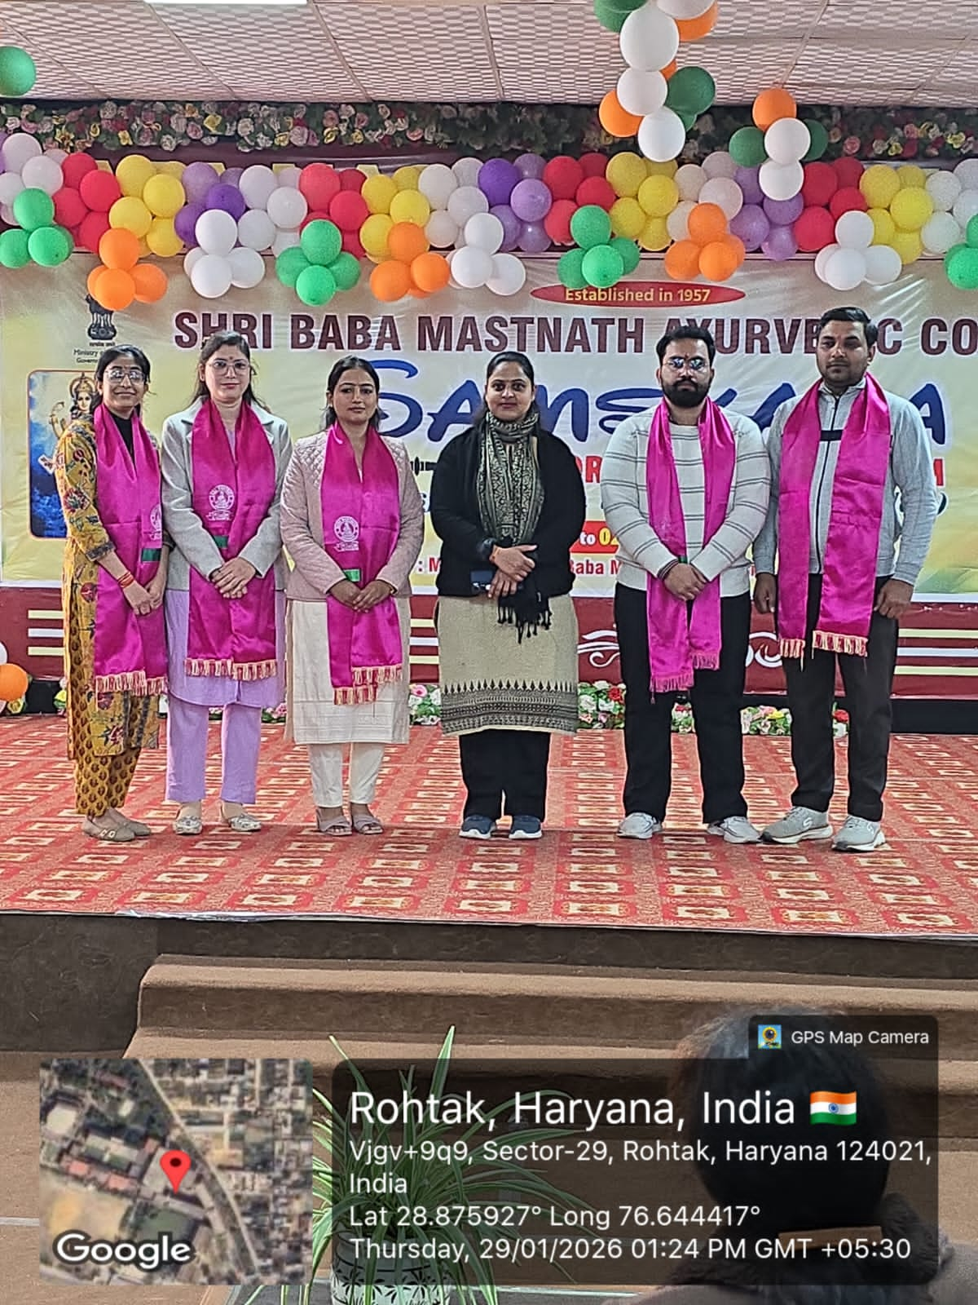

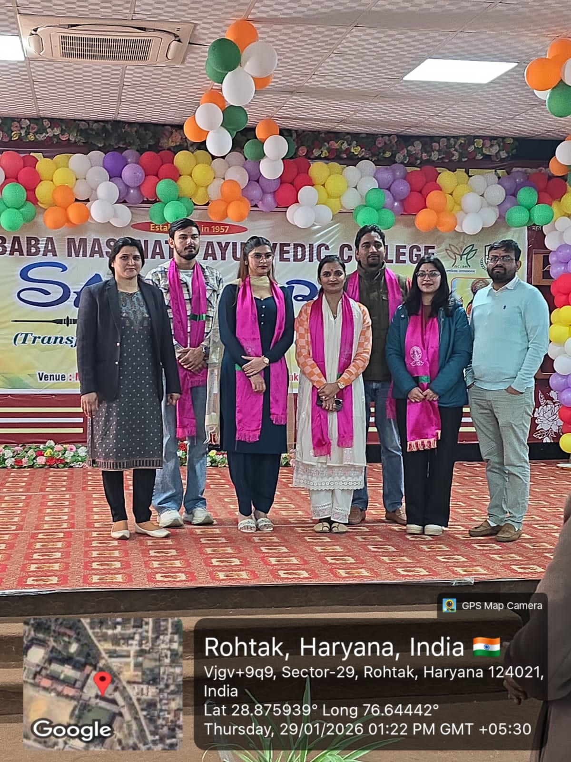

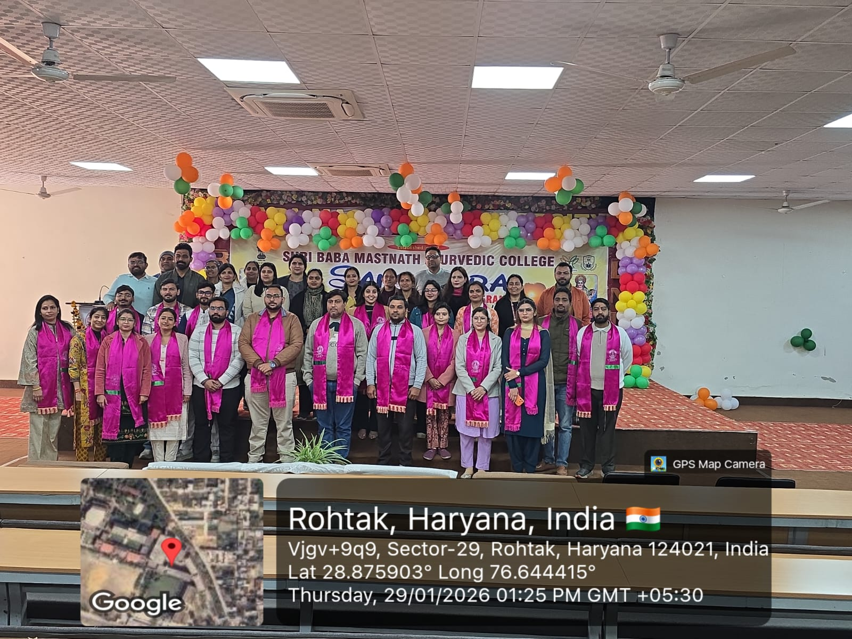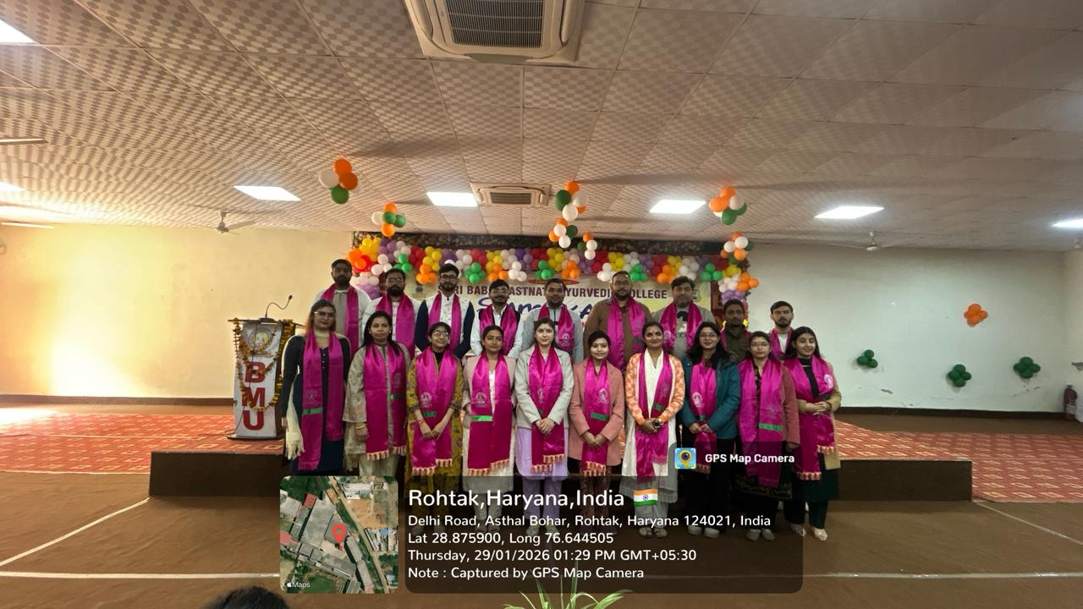 GUEST FACULTY SPEAKER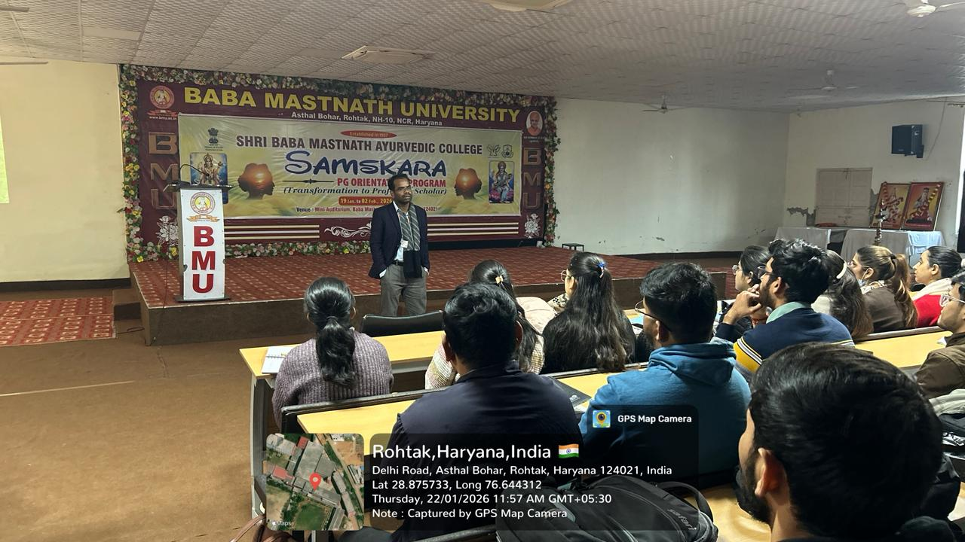

SPEECH BY VICE CHANCELLOR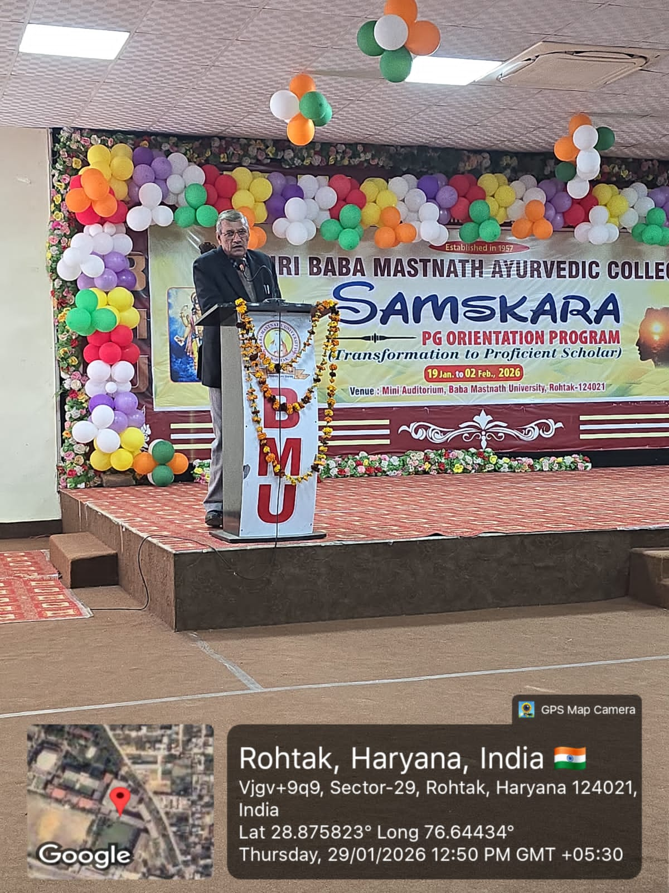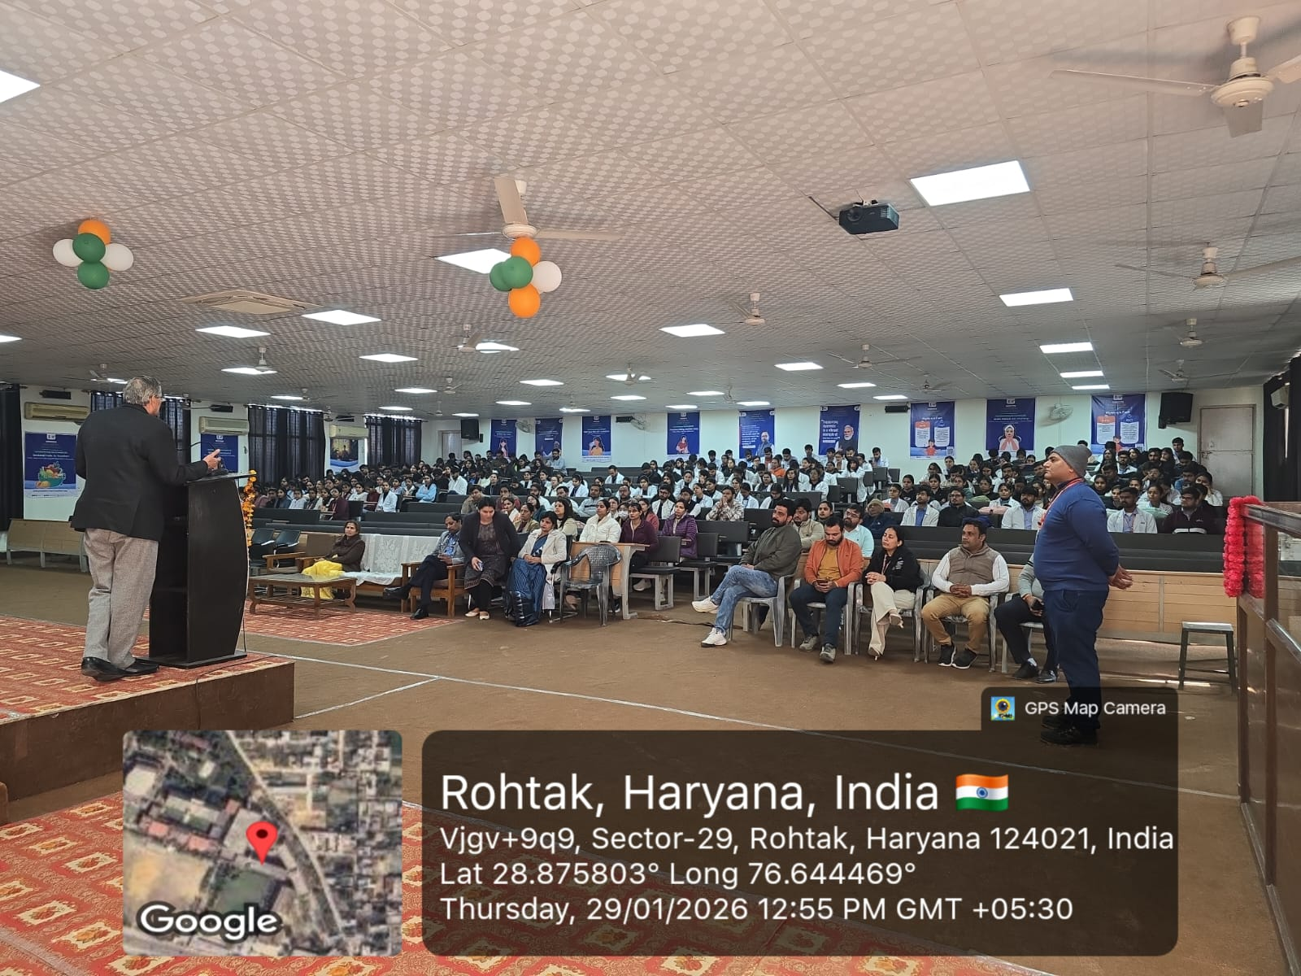
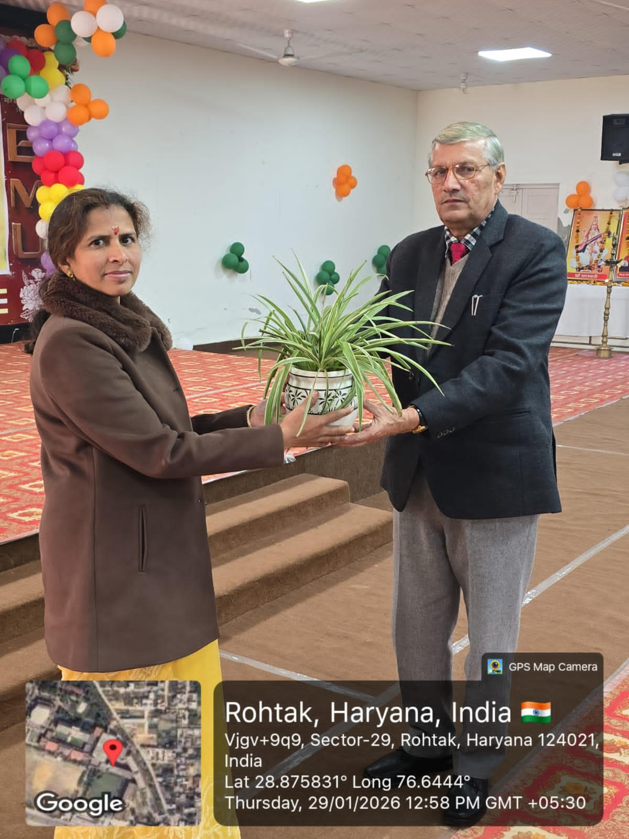
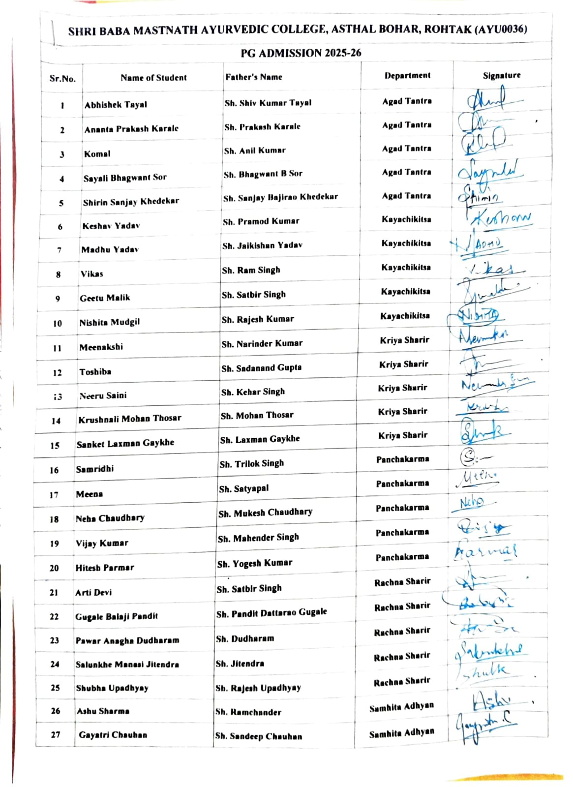
SUMMARY OF PROGRAM

The Postgraduate Orientation Program held on 31 March at Shri Baba Mastnath Ayurved College was successfully organized to welcome and familiarize newly admitted PG students with the institution and its academic environment. The program was organized by Dr. Chandranshu Shukla, Assistant Professor, Dept. of Panchakarma, under the guidance of the Principal, Dr. Manish Sharma, with Dr. Anupama Patra serving as the Convenor and Dr. Deepak as the Co-convenor of the event. The program commenced with an inauguration ceremony, followed by a formal welcome session for the students.
The occasion was further enriched by a series of guest lectures delivered by esteemed faculty members, along with an inspiring address by the Honorable Vice Chancellor. A pre-test was conducted on the first day of the session to assess the baseline knowledge of the PG students, and a post-test was conducted on the last day to evaluate their learning outcomes and overall improvement. These sessions provided valuable insights, guidance, and motivation to the newly admitted PG students. The recitation of the Kulgeet added a traditional and cultural touch to the program.
The event concluded with a closing ceremony, marking the successful completion of the orientation. Throughout the program, active participation of students and faculty was evident, and moments were captured through group photographs and event documentation. The attendance sheet was maintained to ensure proper record-keeping. Overall, the orientation program served as a valuable platform to introduce PG students to the academic framework, institutional values, and opportunities ahead, helping them begin their postgraduate journey with clarity and motivation.

